**Heuristic Analysis**

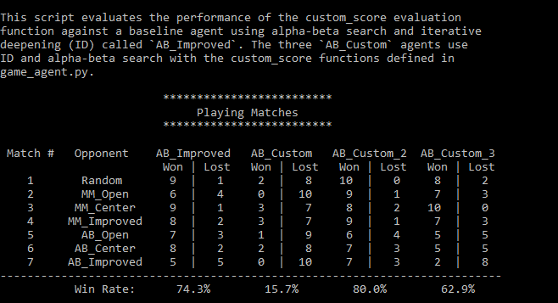

Based the above output from the tournament, we recommend using **AB_Custom_2** evaluation function, with a win rate of 80%, for the following reasons:

* It implements the strategy of maximizing the chances of active player having most number of moves available in the end to win the game.
* The active layer with the most number of moves than the opponent has an advantage, and this is represented by assigning a score of +4. When player is not active but has more number of moves than opponent, there is a slight disadvantage but it’s still favorable to the player. This is shown by assigning a score of +2. The most disadvantaged position for the player is when he is inactive and has least number of moves than the opponent. Such moves are penalized by assigning a score of -4.
* When looking at the win rates just for AB_* opponent matches, the win rate for AB_Custom_2 and AB_Improved are very similar. This could be due to the nature of both evaluation functions where they both look at the relative advantage of the player in-terms of moves, and improved score has more variation in-terms of magnitude of improvement, whereas AB_Custom_2 assigns fixed scores regardless of magnitude of variation.

AB_Custom_3 is the second function among the three custom functions with a win rate of approx.63%. AB_Custom_3 score looks at if the current player can attack the opposition by looking at overlapping moves and moving there on the consequent turn.

AB_Custom is the least performing evaluation function with a win rate of approx.16%. This was meant to be an implementation of weighted scoring functions, and it will need further revision in-terms of appropriate weights tuning and assignment to make it more competitive.